**SORTING ALGORITHMS**

**AND**

**BRUTE FORCE ATTACK**

**Group 5**

Aguirre, Maria Isabela C.

Castillo, Czarina G.

Lagundino, Marithe Ygraine

Reyes, Angel Troy M

(CS0007)

ALGORITHM

Sorting is nothing but arranging the data in a descending or ascending order. There are many different techniques available for sorting, differentiated by their efficiency and space requirements. The aim of sorting is to arrange data in a sequence which makes searching easier. There are so many things in our life that we need to search for, like a particular context on a book, a particular number in a telephone directory etc. With the concept of brute force it is a straight forward approach usually based directly on a problem statement.

WALKTHROUGH OF THE PROGRAM

1. Initially you will be greeted by this frame which. It contains the different buttons of the sorting technique and the application of brute force.

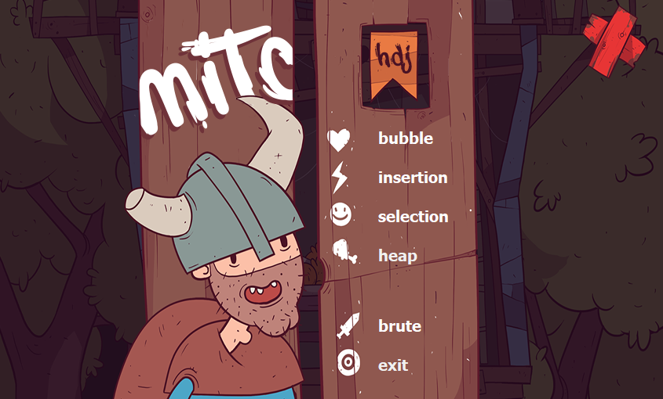

This button is will direct you to our application on brute force

This buttons are the sorting techniques we choose.

**Bubble Sort –** comparison of adjacent elements and exchanging it. This procedure is done repeatedly and ends up with placing the largest element to the n position whether it’s in ascending or descending **Insertion Sort –** the general idea for insertion is that for each element find the place where it belongs. Array elements have to be shifted to the right to make space for insertion. **Selection Sort –** it is an in-place comparison-based algorithm in which the list is divided into two parts, the sorted part at the left end and the unsorted part at the right end. **Heap Sort -**  is divided into two basic parts: Creating a Heap of the unsorted list/array. Then a sorted array is created by repeatedly removing the largest/smallest element from the heap, and inserting it into the array. The heap is reconstructed after each removal.

1. If you choose one of the sorting techniques it will directly go to this frame. In which you will initialize your list.

When you pressed the sort button it will sort your created list.

As you pressed the add button it will automatically be transferred in this text area

This area is where you will type your list.

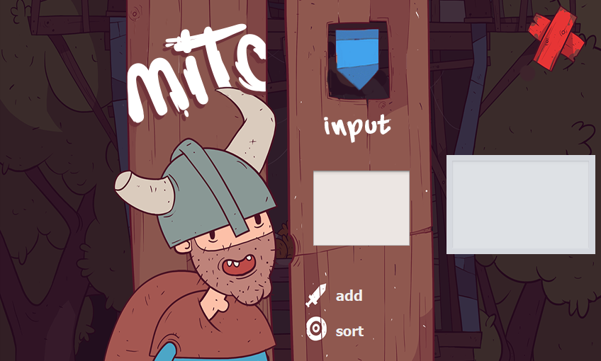

1. Once you pressed the sort button it will directly go to this frame. Wherein you will see your list in an ascending and descending manner.

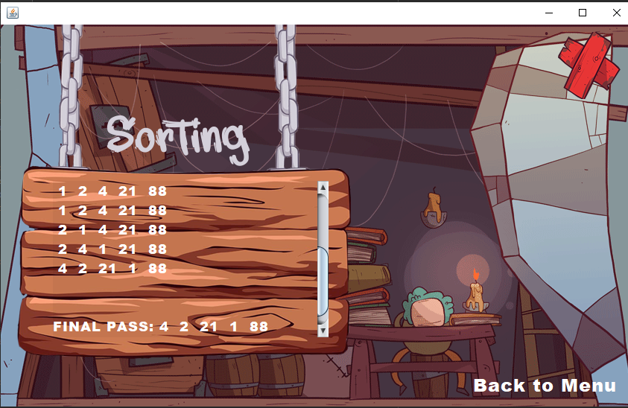

In this you will see your list in an ascending and descending and it will also show each passes before sorting.

You will be redirected in the main Menu.

1. When you pressed the Main Menu you can click the button brute to see the group’s application in brute force.

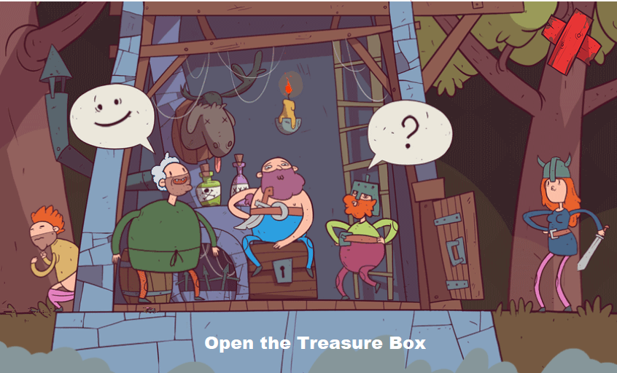

When you pressed the treasure box the user will be redirected to the brute force application.

In this search field you will input a word, letter, sentence you want to find in the book.

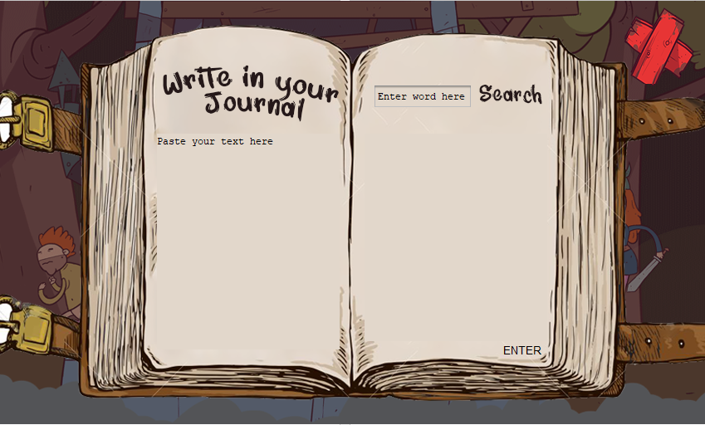

As you pressed the search button you will automatically see a highlighted words which is the user is looking for.

This part of the book is where you will paste your text.

**Screenshots of the Project**

1. Bubble Sort

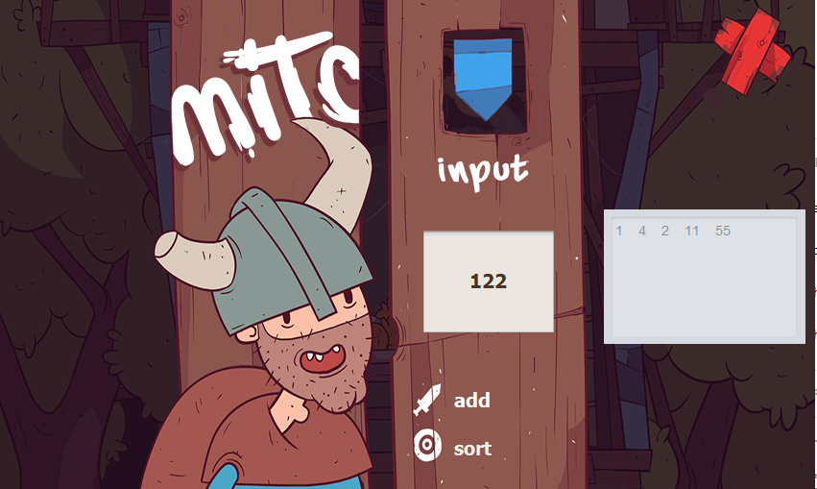

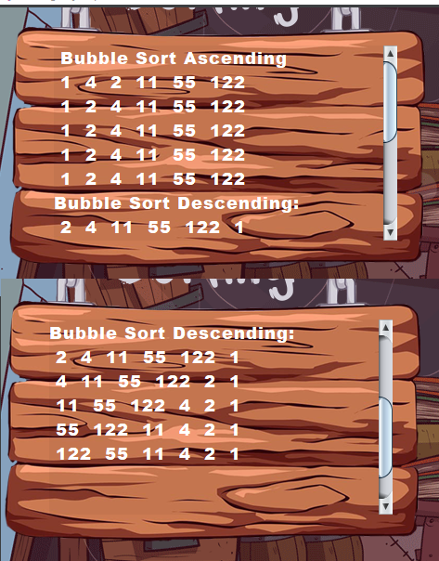

1. Insertion Sort

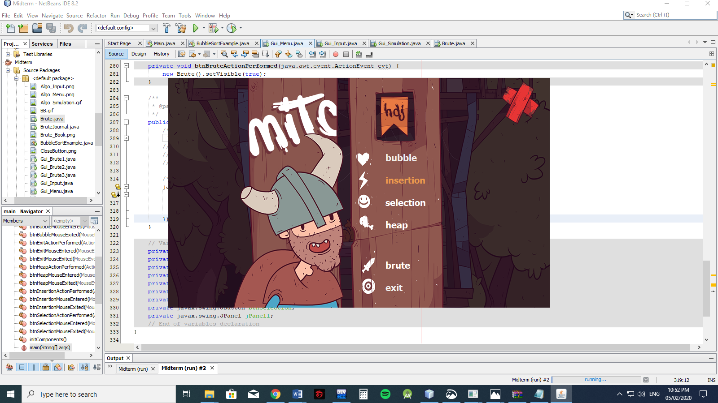

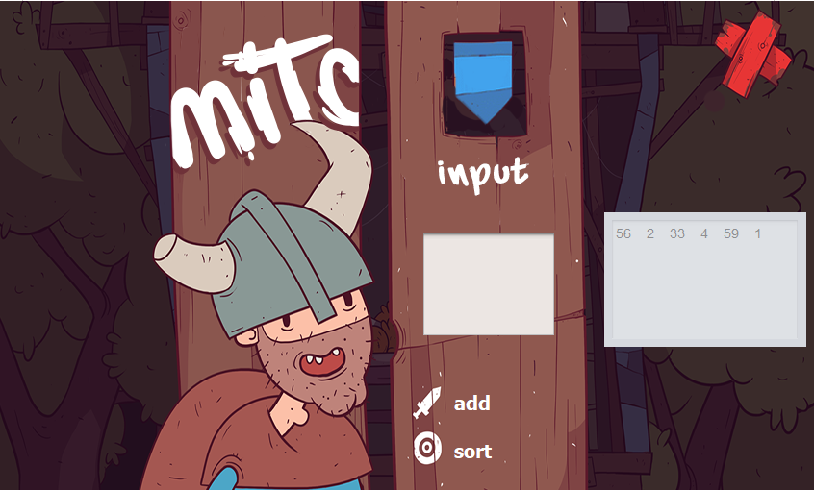

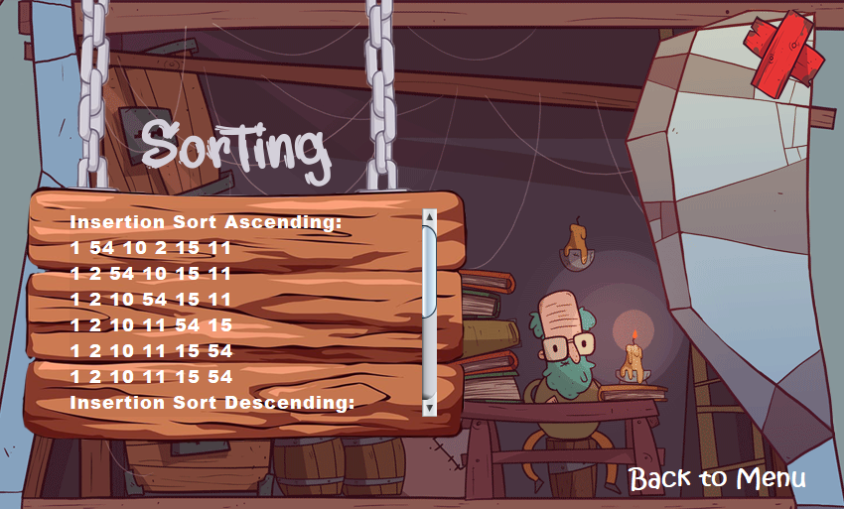

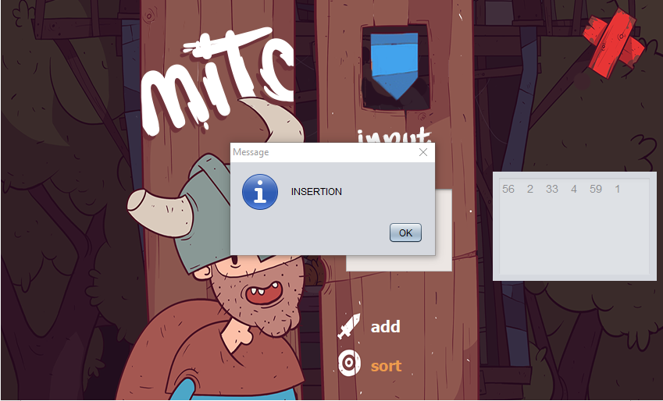

1. Selection Sort

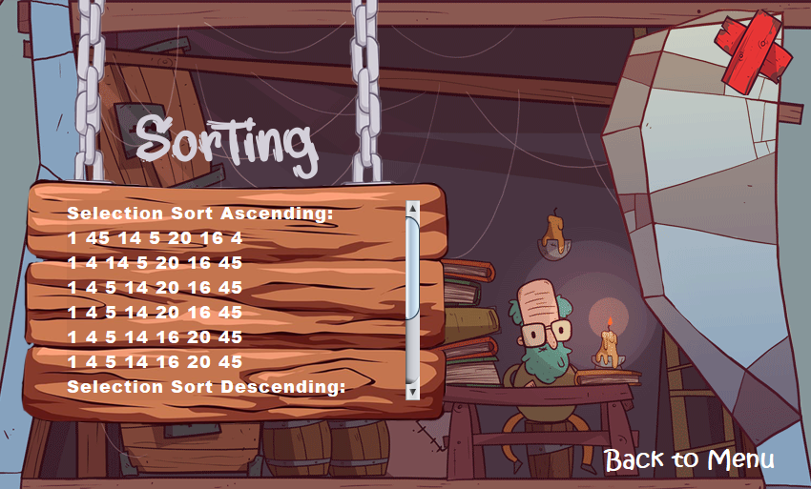

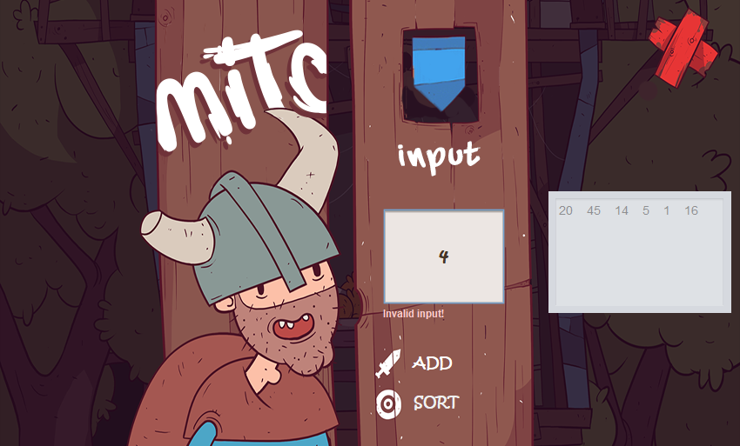

1. Heap Sort

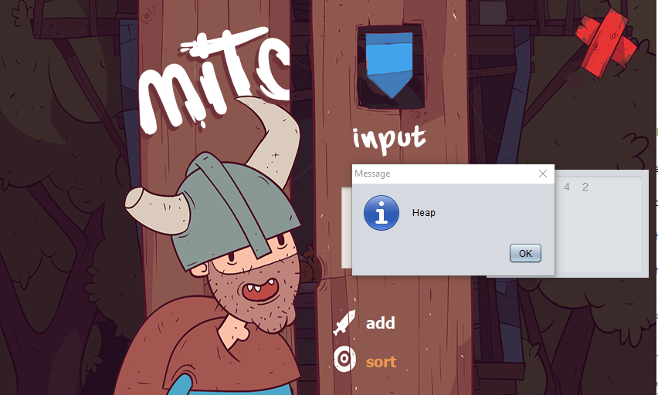

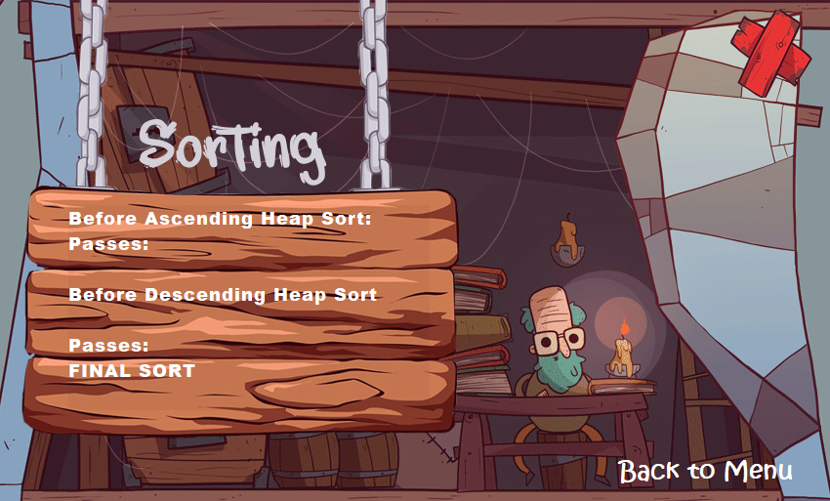

1. Brute Force Application

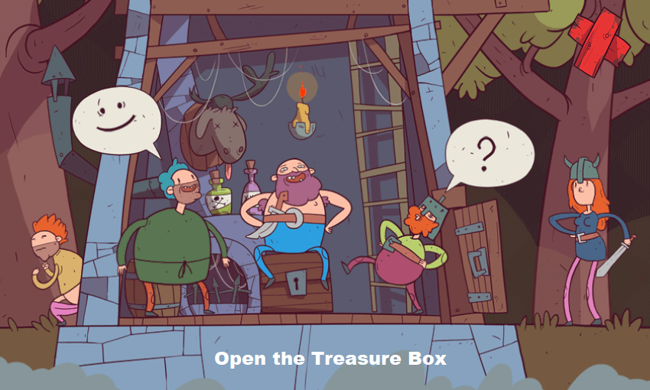

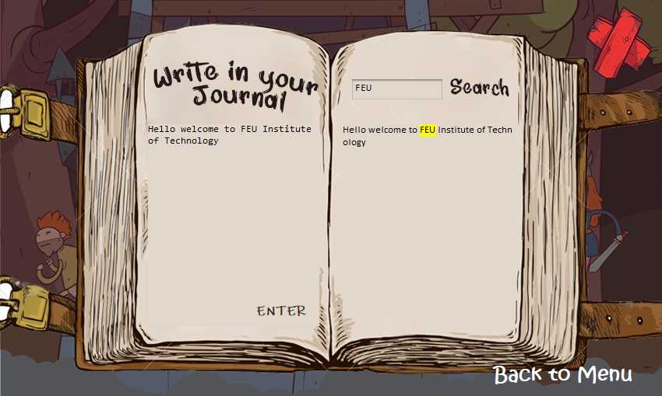

**BRUTE FORCE STRING MATCHING**

* Brute force string matching is an algorithm in which it search all the possible string in a large given of text. Brute-force string matching compares a given pattern with all substrings of a given text. Those comparisons between substring and pattern proceed character by character unless a mismatch is found. Whenever a mismatch is found, the remaining character comparisons for that substring are dropped and the next substring can be selected immediately. As the user input any string in the search field in the application all string that is matched in the search field will be highlighted and it will show all possible matches in the book.